Lecture #2 - Review classes, polymorphism and virtual functions
Output:
ID: 123456
Type: Automobile
Mfr: Ford

- Create a new program using classes described in
the following UML diagrams. Program OUTPUT

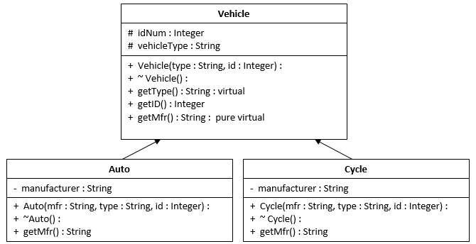

- Include the following 6 files:
- Vehicle.h - Declare a Vehicle class
      - int getID() - Returns the vehicle ID
Note: Auto and Cycle classes have no getID() method.
The base class (Vehicle) method is inherited by both classes.

      - int getType() - Returns the type of vehicle (like auto or motorcycle).
Note: Auto class and Cycle classes do not have a getType function, but
the Vehicle class does.
- Therefore, both classes inherit the getType() function.

      - string getMfgr() - Declare as a pure virtual function.
Note: The getMfgr() function is declared as pure virtual. The function
does not have an implementation.
Therefore, the Auto and Cycle classes must have their own
getMfgr() functions.

- Auto.h - Declare an Auto class
    - Data member: manufacturer (string) - (Ford, GM, Toyota, etc.)

- Auto.cpp - This file contains the method definitions described in Auto.h
The displayVehicle() function in main() produces the following output:
ID: 123456
Type: Automobile
Mfr: Ford

- Cycle.h - Declare a Cycle class specification
    - Data member: manufacturer (string) - (Yamaha, Honda, etc.)

- Cycle.cpp - This file contains the function implementations
The displayVehicle() function in main() produces the following output:
ID: 654321
Type: Motorcycle
Mfr: Honda

  - Source.cpp - main()
    - Declare an object of Auto type and name it: myRide
      - Pass the following to the overloaded constructor:
("Ford", "Automobile", 123456)
    - Declare an object of Cycle type and name it: yourRide
      - Pass the following to the overloaded constructor:
("Honda", "Motorcycle", 654321)

    - Display information about the myRide object by calling displayVehicle().
      - Pass myRide to the function. (see the output above)

    - Display information about the yourRide object by calling displayVehicle().
      - Pass yourRide to the function. (see the output above)

    - Include the following displayVehicle() function in main.cpp (next page)
    - Notice that the parameter is a Vehicle reference variable.
      - The correct getMfr() function will be called based on which derived class object
is passed to the function. This is a form of polymorphism.

void displayVehicle(Vehicle & vehicle)
{
cout << “ID: ” << vehicle.getID() << endl
<< “Type: ” << vehicle.getType() << endl
<< “Mfr: ” << vehicle.getMfr() << endl;
}

Source code:
